INSTAGRAM USER ANALYTICS
By- Pratham Mehta

Project Description
This project aims to analyze user interactions and engagement on the Instagram app to generate valuable insights that can drive business growth. Using MySQL Workbench as the primary analysis tool, we will delve into Instagram user data to answer specific questions posed by the management team. By uncovering trends and patterns in user behavior, content performance, and engagement metrics, the project will provide the product manager and the broader team with data-driven insights. These insights will inform strategic decisions, guiding the future development and direction of the Instagram app to better meet user needs and enhance overall engagement.
Approach
The approach was to filter out the data with the help of different type of query commands like “joins” which include the concepts of primary key and foreign keys and using these concepts in inner-joins and left-joins and “group by” query commands were used to remover or count recursive datasets. With the help of these commands the data was much cleaner and easier to analyze and extract insights from it, making the work more efficient.
Tech Stack Used
The software used for this project is MYSQL Workbench 8.0 CE. MYSQL is one the best open-source software in the market in its field and it provides various query language controls like DDL, DML and DCL. Along with it, it is also beginner friendly and is most used and sought by beginners as there is a huge community of it and because of which if there are any problems or issues the community has a solution for it.
Insights
The data used helped us gain insight into the user activity and other activities on the platform.
- Loyal User Reward: With the help of the data, we tracked our oldest customers who have been with us for a long time and for their loyalty we provided them with some rewards for their loyalty.
- Inactive User Engagement: Identified users which are not active on the platform and sent them promotional mail regarding their engagement on the platform and promoting them to engage with the platform more.
- Contest Winner Declaration: With the help of query commands, we could find out the user with most likes on single photo on Instagram. Which helped in finding the winner for the Contest. The winner is Zack_Kemmer93 with 48 likes.
- Hashtag Research: During the hashtag research we came across 5 hashtags which are being used the most. Smile being the most used hashtag while the rest were beach, party, fun and concert.
- Ad Campaign Launch: For an upcoming ad campaign, the most suitable days with most user engagement in joining of new users are Thursday and Sunday.
- User Engagement: There are 2.57 no. of post of photos per user according to the data. Where the total no. of users is 100 and the total number of posts is 257.
- Potential Identification of Bots: According to the data provided there were no bots as such suspected or identified.

Snapshots
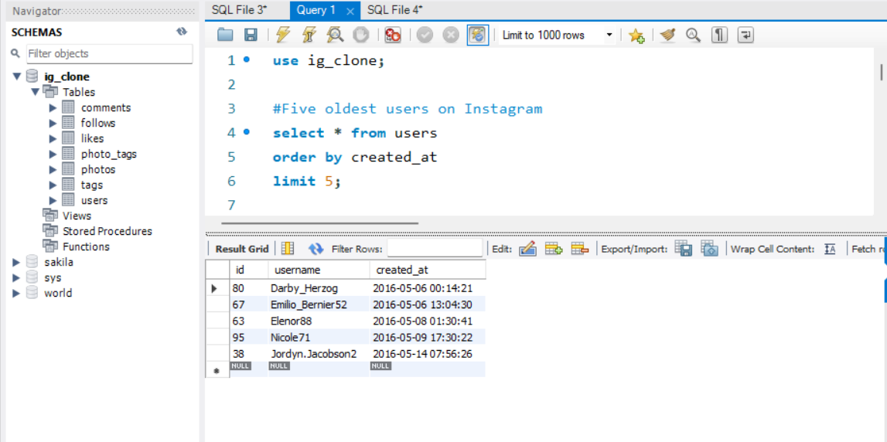
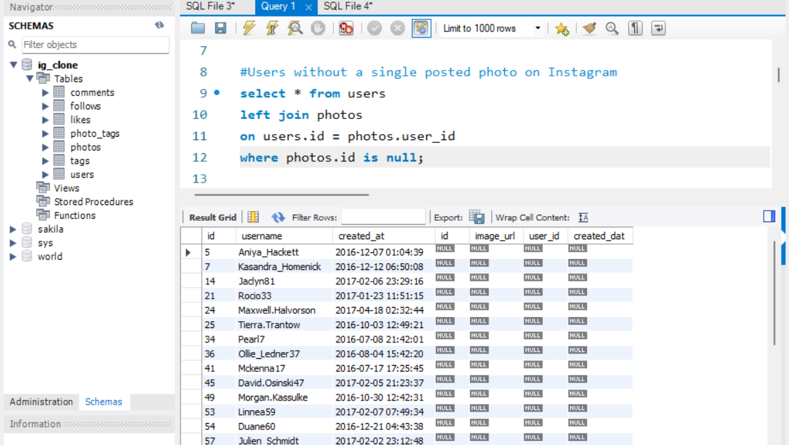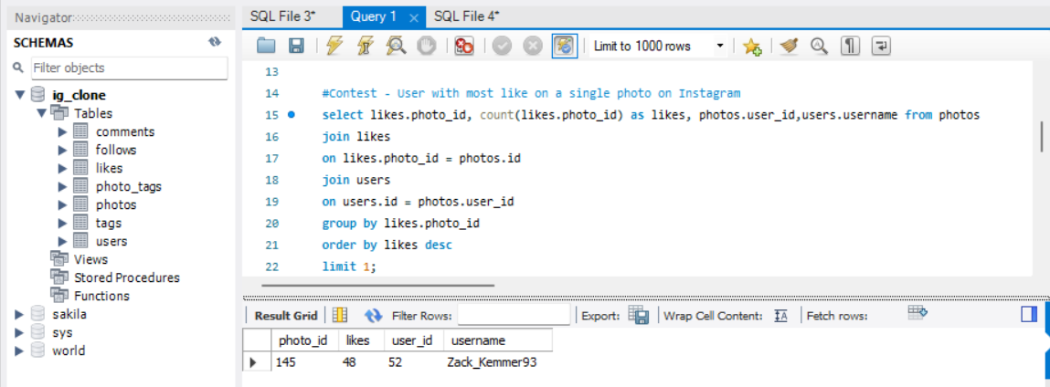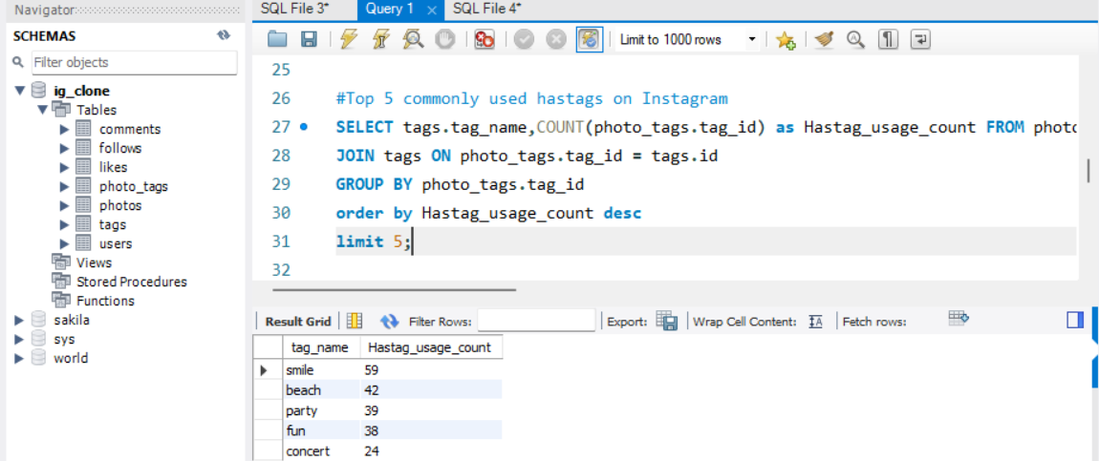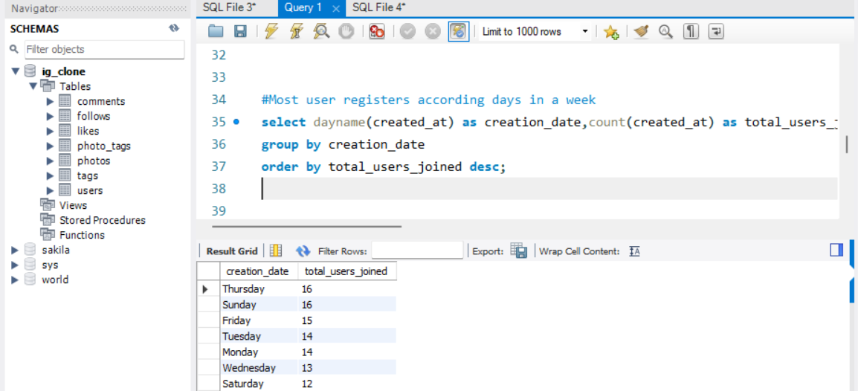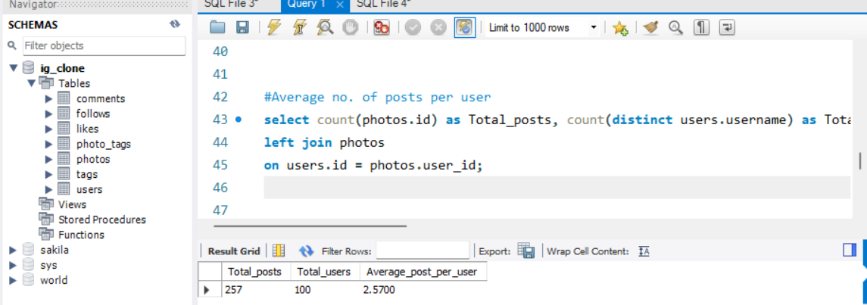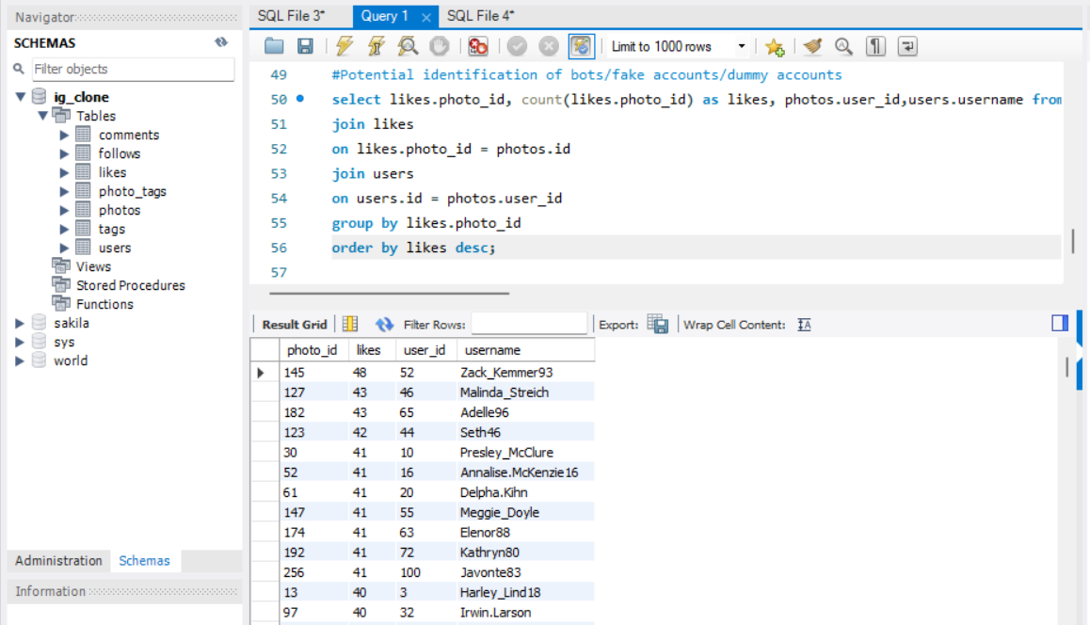
Results
With the help of the analysis of the given data we have uncovered some important insights. Insights like users who are inactive on platform and users who have been with us since long time because of these data we could make attempts to approach both kind of users and reach them out with the respective measures like Loyalty program for the loyal users and reaching inactive users.
Also finding potential bots or fake accounts and identifying which day of the week the newest users enroll to the platform, helping in launching ad campaigns for new user attractions.

